Supply curve analysis

Author: Mikhail Kalialin

Background.
This project analyses NEM bid data to reconstruct supply curves, identify price-setting generators, and assesses the impact of counterfactual scenarios, including hypothetical wind generation and BESS operation.

Task 1- reconstruct the ENERGY supply curve for each region
Based on the analysis of bid and dispatch data for 26 June 2025, it appears that during the evening peak period a significant portion of generation capacity was committed to FCAS. As a result, the market clearing price was influenced not only by energy requirements but also by the provision of ancillary services.
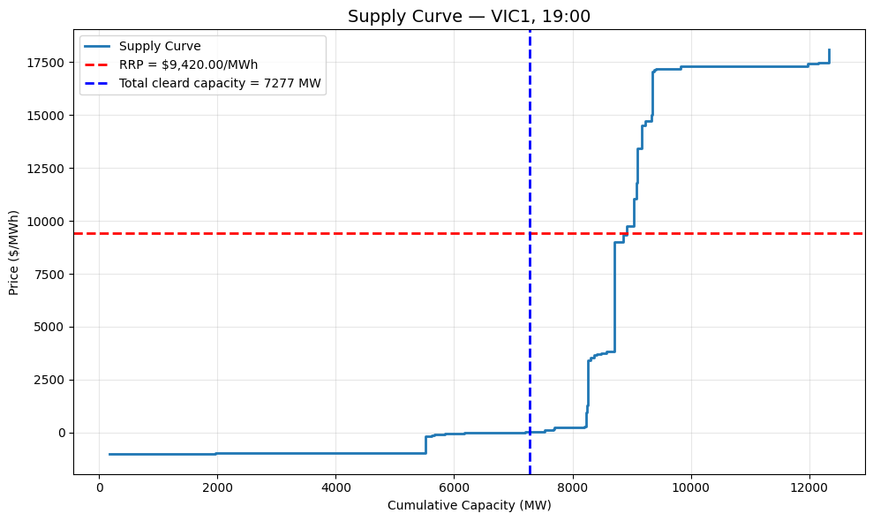

Task 2- price setting
The dataset includes generation units in Victoria only, which limits the ability to provide a per-region breakdown. Within Victoria, Newport Power Station (NPS), a gas-fired generator, was the most frequent price setter on 26 June 2025. Overall, gas-fired generators dominated price-setting activity throughout the day.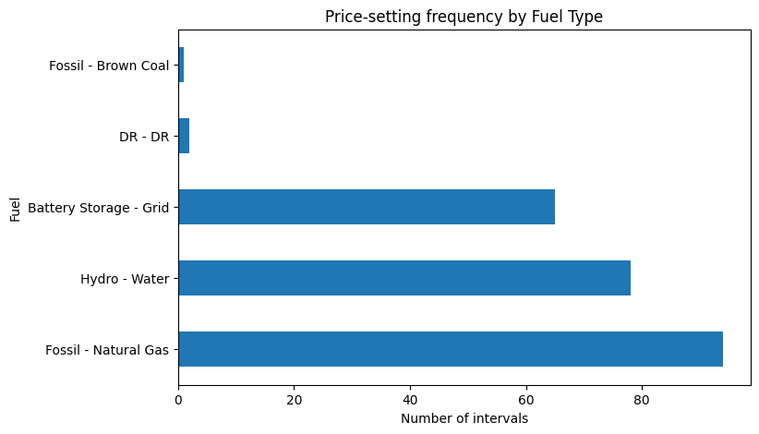

Task 3 - Revenue vs. Price setting:
The analysis indicates that coal and gas-fired units earned the highest total revenue, as expected in the NEM. Notably, BESSs display a linear relationship between revenue and price-setting frequency, with their earnings increasing proportionally the more often they acted as price setters.
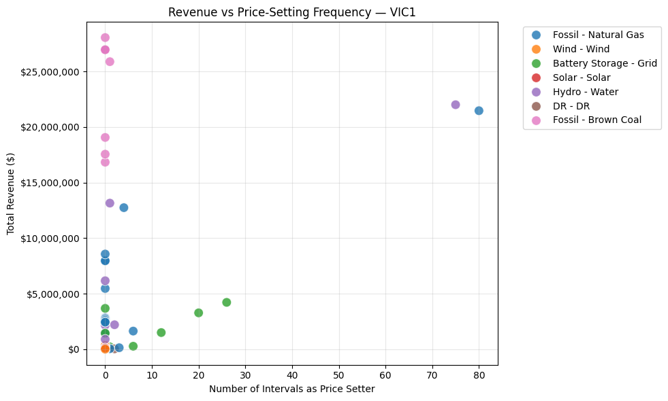

Task 4

Counterfactual supply scenario - 100 MW wind generator
On 26 June 2025 at 20:30, it is assumed that a significant portion of generation was committed to FCAS. While the energy requirement for the interval was 6,726 MW, the marginal price was set by units dispatched at 8,001 MW. This indicates that the additional 1,275 MW was effectively committed to FCAS rather than energy.
To evaluate the impact of adding a hypothetical 100 MW wind generator bidding at $0/MWh, I adjusted the supply curve to include this additional capacity. The resulting marginal price shift was calculated not at the intersection corresponding to the energy-only requirement of 6,726 MW, but at the intersection of the adjusted supply curve and the total marginal volume of 8,001 MW (including the FCAS-committed volume).
This approach accounts for the fact that the marginal unit setting the price reflects both energy and FCAS commitments, rather than energy alone.
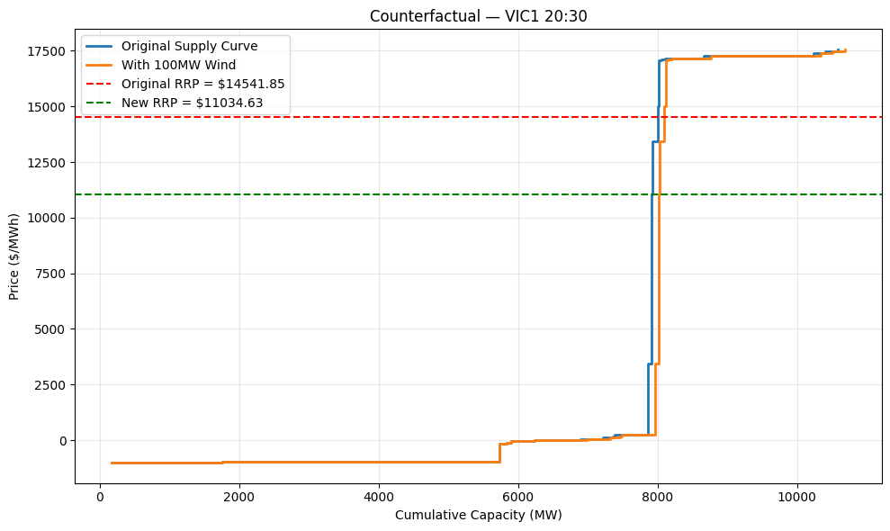

BESS bidding at 20:30 and 19:00
In the given scenario, the battery bidding would depend of a few factors, including
- Risk appetite of the BESS operator
- Bid bands submitted before
A balanced approach would be to spread the bids across multiple price bands. Specifically:
- Place bids ~$1,500/MWh below the forecast price, reflecting the historical negative difference between RRP and forecasted RRP observed between 18:45–20:45. This suggests that the forecast may be slightly overstating prices.

- Place additional bids closer to the forecasted clearing price to either influence the market price or ensure dispatch at a price near the interval’s potential maximum revenue.
At 20:30 it is reasonable to bid more aggressively (push volume into bands at or just below the clearing price to ensure dispatch and capture the high spot)
At 19:00 in general bid should more conservative/staggered, keeping headroom for later higher-price intervals, and at the same time securing revenue at relatively high prices too.
